GGM THAI TRAVEL: OPTIONAL PRICE LIST

Valid from: Now - 31 OCT’ 2025
Rate (Thai baht)

Transfers by VAN
Description | Van 9 seat
Airport -hotel or Hotel -Airport | 1,500
Bangkok one day 8-10 Hrs. | 4,000
Outside Bangkok one day 08-10 hrs.. | 4,500
Tipping for guide & Driver | 100 per person/day
Guide Fee | 2,000 per day
Transfers by Coach
Description | Bus 35-45 seat
Airport -hotel or Hotel -Airport | 9,000
Bangkok one day 8-10 Hrs. | 12,000
outside Bangkok one day 08-10 hrs.. | 13,000
Tipping for guide & Driver | 100 per person/day
Guide Fee | 2,500 per day

VIP VAN rental

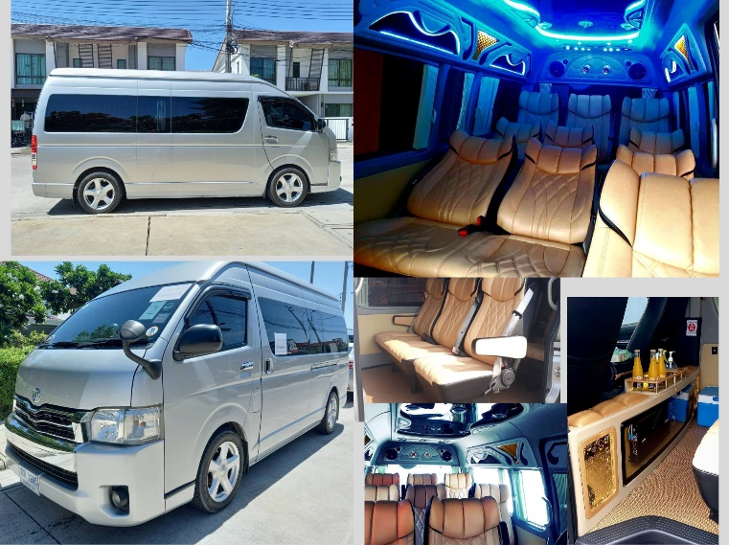

Transport

